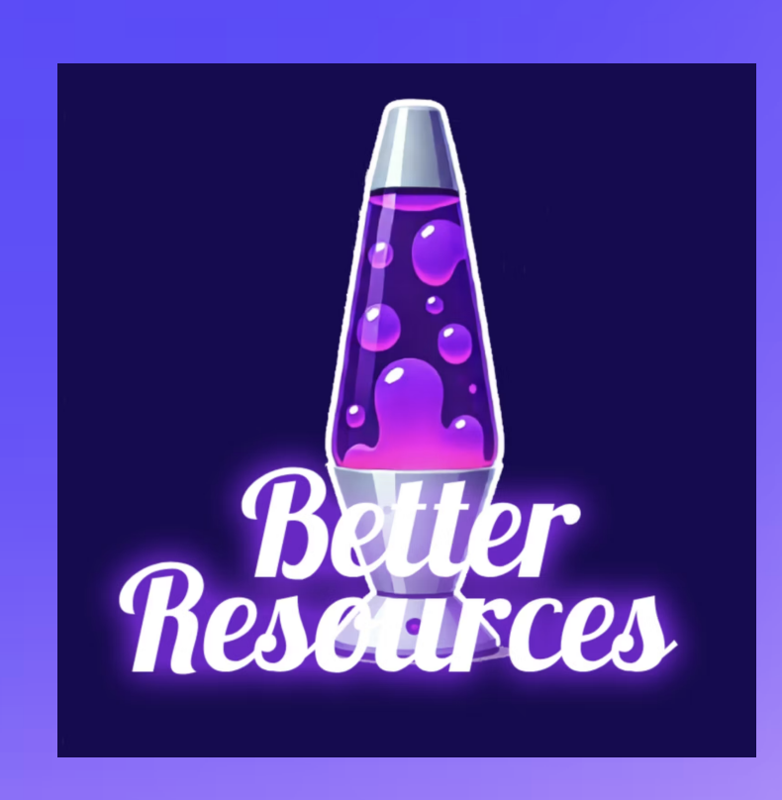

BetterResources – Event Strategy Plan

**Event Name:** ___________________________________________
**Event Date:** ____________________________________________
**Event Location:** _________________________________________

1. Before the Event
☐ Research the event audience and partners
☐ Prepare BetterResources marketing materials (flyers, QR codes, swag, etc.)
☐ Promote attendance on social media (Instagram, LinkedIn, etc.)
☐ Confirm download links & app demo ready
☐ Assign team roles (outreach, demo, sign-ups)
Notes: _____________________________________________________

2. Goals at the Event
Main Goal: ________________________________________________
Number of App Downloads Target: ________ (e.g., 50+)
Networking Goals: __________________________________________
Partnerships/Leads to Meet: _________________________________

3. During the Event
☐ Engage attendees with demos & conversation
☐ Distribute QR codes for instant downloads
☐ Collect contact info (email, phone, LinkedIn)
☐ Track downloads in real time
Notes: _____________________________________________________

4. After the Event (Follow-Up)
☐ Send thank-you emails or LinkedIn messages
☐ Share recap on social media
☐ Measure total downloads gained
☐ Add leads to outreach/funding pipeline
☐ Schedule follow-up calls or demos
Action Items: _______________________________________________

✔️ Reminder: Always represent BetterResources professionally—our mission is to make mental health, academic, and financial resources accessible to all.

